Transforming Polynomial Functions
TEKS: P1.A, P2.A

Content Objective: I will be able to transform polynomial functions.

Language Objective:

I. Lesson

Transformations for polynomial functions follow the same rules as quadratic functions.

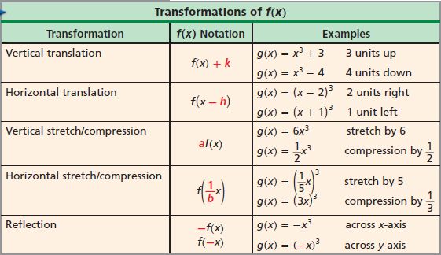

EXAMPLE 1: Transforming Polynomial Functions
Graph the parent function, the transformed function, describe the transformation, and state the domain and range.
$$x$$
$$y$$

A) $f\left(x\right)=x^{3}+7$

Try It
$$x$$
$$y$$

B) $f\left(x\right)={\left(x-5\right)}^{3}$

C) $f\left(x\right)={\left(x+3\right)}^{4}-5$

$$x$$
$$y$$

$$x$$
$$y$$

D) $f\left(x\right)=3x^{3}+1$

E) $f\left(x\right)=-\frac{1}{4}\left(x-5\right)+3$

$$x$$
$$y$$

$$x$$
$$y$$
F) $f\left(x\right)={\left(\frac{1}{4}X\right)}^{3}-4$

G) $f\left(x\right)=-{\left(\frac{1}{3}x+2\right)}^{3}-5$

$$x$$
$$y$$

NAME: DATE: PERIOD:

Independent Practice: Transforming Polynomial Functions

Graph the parent function, the transformed function, describe the transformation, and state the domain and range.

- $f\left(x\right)={\left(x-3\right)}^{3}$
- $f\left(x\right)=x^{3}-3$
- $f\left(x\right)=\frac{1}{2}x^{3}$
- $f\left(x\right)=\frac{1}{2}x^{4}$
- $f\left(x\right)={\left(x-1\right)}^{4}+2$
- $f\left(x\right)=-2{\left(x+1\right)}^{3}+2$
- $f\left(x\right)=-\frac{1}{4}x^{3}+2$
- $f\left(x\right)=-{\left(x+2\right)}^{3}-1$
- $f\left(x\right)={\left(x-2\right)}^{3}+2$
- $f\left(x\right)=-x^{3}-1$
- $f\left(x\right)=\frac{1}{2}{\left(x+1\right)}^{3}-2$
- $f\left(x\right)=-{\left(x-1\right)}^{4}-1$
- $f\left(x\right)=-2x^{4}$
- $f\left(x\right)=3{\left(x-20\right)}^{4}+10$
- $f\left(x\right)=\frac{1}{2}{\left(x-3\right)}^{3}+1$
- $f\left(x\right)=3{\left(x-1\right)}^{4}$
- $f\left(x\right)={\left(x-3\right)}^{3}+2$
- $f\left(x\right)=\frac{1}{3}{\left(x-2\right)}^{4}+1$
- $f\left(x\right)=\frac{1}{3}{\left(x-4\right)}^{3}-2$
- $f\left(x\right)=-{\left(x+8\right)}^{4}+5$

