Investigating Graphs of Polynomial Functions
TEKS: P1.A, P1.B, P1.C, P1.D, P1.E, P3.A, P3.D

Content Objective: I will be able to use properties of end behavior to analyze, describe, and graph polynomial functions. Identify and use maxima and minima of polynomial functions to solve problems.

Language Objective:

I. Vocabulary

End Behavior:
Turning Point:
Local Maximum:
Local Minimum:

II. Lesson

Notice the characteristics of the Polynomial Functions.

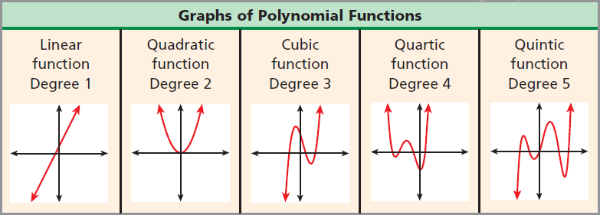

Some key characteristics to point out are:
1. Degree $≥$ real x-intercepts,
2. Degree – 1 = Vertices,
3. Odd degree polynomials have range = all real numbers.

The range of the polynomials relates to the end behavior of the graphs.

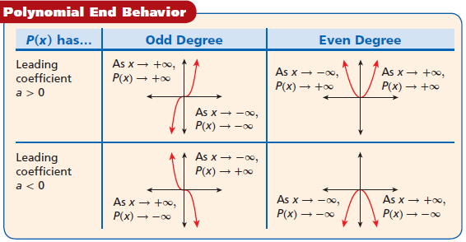

Notice odd degree polynomials have opposite end behavior.
Even degree polynomials have same end behavior.

You can describe a polynomial’s end behavior by simply looking at the degree and leading coefficient.

EXAMPLE 1: Determining End Behavior of Polynomial Functions
Identify the leading coefficient, degree, and end behavior.

A) $P\left(x\right)=-4x^{4}-3x^{3}+x^{2}+4$

Try It

A) $P\left(x\right)=x^{5}-4x^{2}+3x-1$

Using end behavior, x-intercepts, y-intercept, and a couple of random points in between, you can make a good sketch of the graph of a polynomial function.

EXAMPLE 2: Graphing Polynomial Functions
Use the x, y-intercepts, end behavior, and a couple of points in between to sketch the graph.
$$x$$
$$y$$
A) $f\left(x\right)=x^{3}+3x^{2}-6x-8$

Try It

A) $f\left(x\right)=x^{3}-2x^{2}-5x+6$
$$x$$
$$y$$

The vertex of a parabola is a turning point and depending on which way the parabola opens it can either be a maximum or a minimum. For polynomials, when there are more than one turning point, they are classified as either a local maximum or local minimum and an interval around that turning point must be given.

EXAMPLE 3: Determine Maxima and Minima with a Calculator
Give all the local maxima/minima.

A) $g\left(x\right)=x^{4}-4x^{3}+3x+5$ B) $f\left(x\right)=2x^{3}-3x^{2}-6x-5$

Try It

A) $f\left(x\right)=9x^{6}+20$ B) $f\left(x\right)=x^{3}-4x^{2}+x+1$

NAME: DATE: PERIOD:

Independent Practice: Investigating Graphs of Polynomial Functions

Use the leading coefficient and degree to identify the end behavior.

- $f\left(x\right)=2x^{2}+3x+3$
- $f\left(x\right)=-4x^{2}-2x+1$
- $f\left(x\right)=6x^{2}-3x^{2}-3x-3$
- $f\left(x\right)=-6x^{3}-2x^{2}+3x+2$
- $f\left(x\right)=2x^{4}-4x^{2}$
- $f\left(x\right)=5x^{4}+5x^{3}+3x^{2}-2x$
- $f\left(x\right)=-4x^{4}+3x^{3}+4x^{2}+3x+5$
- $f\left(x\right)=5x^{3}+5x^{2}+3x+3$
- $f\left(x\right)=x^{3}-4x^{2}+4x-5$
- $f\left(x\right)=-3x^{3}-2x^{2}+3x-3$

Graph the polynomial function.

- $f\left(x\right)=x^{4}-4x^{2}$
- $f\left(x\right)=2x^{2}-x^{3}$
- $f\left(x\right)=\frac{1}{3}-\frac{1}{3}x^{4}$
- $f\left(x\right)=x^{3}+5x^{2}-x-5$
- $f\left(x\right)=x^{3}+2x^{2}-5x-6$
- $f\left(x\right)=4x-x^{3}-x^{5}$
- $f\left(x\right)=-6x^{4}+9x^{3}$
- $f\left(x\right)=6x^{3}-6x-x^{5}$
- $f\left(x\right)=x^{4}-4x^{3}+4x^{2}$
- $f\left(x\right)=x^{5}-3x^{3}-40x$

Use a graph on the calculator to estimate the relative maxima and minima.

- $f\left(x\right)=x^{3}-3x^{2}+1$
- $f\left(x\right)=x^{3}-12x+2$
- $f\left(x\right)=2x^{3}+3x^{2}-12x+1$
- $f\left(x\right)=2x^{3}-15x^{2}+24x+19$

